**Netaji Subhash Engineering College**

**Department of Computer Science & Engineering**

**B. Tech CSE 2nd Year 3rd Semester**

**2021-2022**

_______________________________________________________________________________________________

**Name of the Course: IT Workshop**

**Course Code: PCC-CS393**

**Name of the Student: Sanjoy Saha**

**Class Roll No.: 3**

**University Roll No.: 10900120003**

**Date of Experiment: 19/11/2021**

**Date of Submission: 24/11/2021**

**_______________________________________________________________________________________**

* **Assignment No.: 21**

**Problem Statement:** Write a program to count the number of each vowel in a sentence.

**Python Code:**

vowels = 'aeiou'

ip_str = input('Enter the string: ')

ip_str = ip_str.casefold()

count = {}.fromkeys(vowels,0)

for char in ip_str:

   if char in count:

       count[char] += 1

print(count)

**Sample Output(s):**

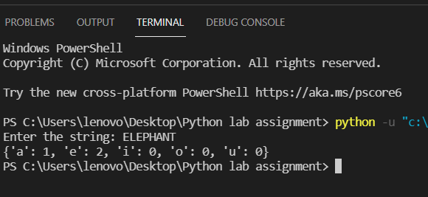

* **Assignment No.: 22**

**Problem Statement:** Write a program to read a string and check whether the string is a palindrome or not.

**Python Code:**

x = input('Enter the string  ')

w = ""

for i in x:

    w = i + w

if (x == w):

    print("Yes")

else:

    print("No")

**Sample Output(s):**

* **Assignment No.: 23**

**Problem Statement:** Write a program to get a string from a given string where all occurrences of the last character have been changed to ‘*’, except the last character.

**Python Code:**

def change_char(str1):

  char = str1[0]

  str1 = str1.replace(char, '*')

  str1 = char + str1[1:]

  return str1

x=input("Enter the string: ")

print(change_char(x))

       greater += 1

print("The L.C.M.of",x,"and",y,"is", lcm)

**Sample Output(s):**

**Assignment No.: 24**

**Problem Statement:** Write a program to count the occurrences of a word in a given sentence.

**Python Code:**

def countOccurrences(str, word):

    a = str.split(" ")

    count = 0

    for i in range(0, len(a)):

        if (word == a[i]):

           count = count + 1

    return count

str =input("Enter the string: ")

word =input("Enter the word: ")

print(countOccurrences(str, word))

**OUTPUT –**

**`**

**Assignment No.: 25**

**Problem Statement:** Write a program to get all substrings of a given string.

**Python Code:**

def subString(Str,n):

    for Len in range(1,n + 1):

        for i in range(n - Len + 1):

            j = i + Len - 1

            for k in range(i,j + 1):

                print(Str[k],end="")

            print()

Str = input('Enter the string: ')

subString(Str,len(Str))

**Sample Output(s):**

**Assignment No.: 26**

**Problem Statement:**  Write a program to detect whether two strings are anagrams or not.

**Python Code:**

def areAnagram(str1, str2):

    n1 = len(str1)

    n2 = len(str2)

if n1 != n2:

        return 0

str1 = sorted(str1)

    str2 = sorted(str2)

       for i in range(0, n1):

        if str1[i] != str2[i]:

            return 0

    return 1

str1 = input("Enter the 1st string: ")

str2 = input("Entre the 2nd string")

if areAnagram(str1, str2):

    print("The two strings are anagram of each other")

else:

    print("The two strings are not anagram of each other")

**Sample Output(s):**

**--------------------END-----------------**